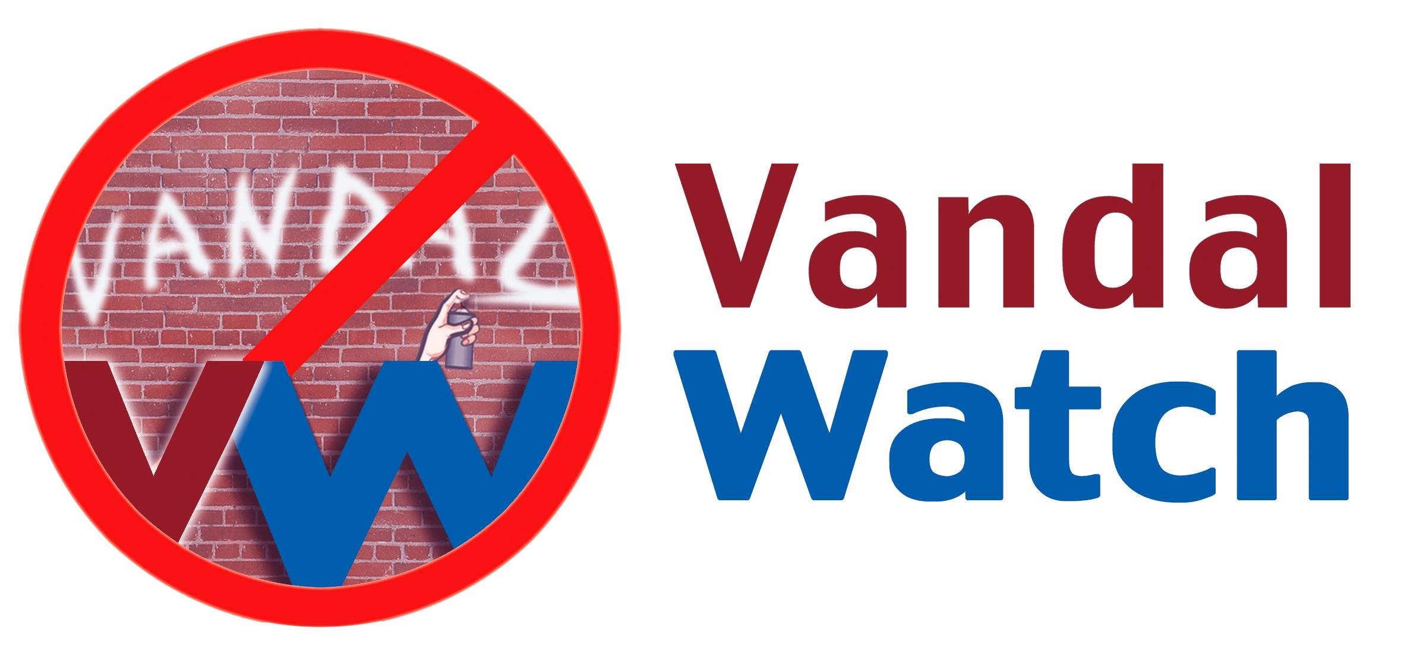

PLEASE HELP LOOK AFTER OUR SCHOOL THIS SUMMER

Our school is an important place in our neighbourhood. We all want to do everything we can to eliminate vandalism on school grounds this summer. Schools are most at risk during:

- Summer evenings and nights especially when the weather is hot
- The week before school opens on Tuesday September 5, 2017
- Friday and Saturday evenings and nights during the month of September

What You Can Do
Keep your eyes and ears open for suspicious activities on the school grounds. Everything you see and hear helps. Note the physical characteristics and clothing of individuals. If you see automobiles, jot down license plate numbers.

Report All Suspicious Activities to the Vandal Watch Tip Line

604-927-7600

Call immediately when something raises your suspicions.
Do not wait for the damage to be done.

Your Call is Anonymous and Confidential

No one will ask for your name or phone number. The Tip Line is available 24 hours a day. Security personnel will investigate and will take action or involve the police. Do not get involved in a confrontation yourself.

KEEP THE TIP LINE PHONE NUMBER HANDY. MAKE SURE THE PHONE NUMBER IS GIVEN ONLY TO RESPONSIBLE ADULTS.



